**The Streaming Balance**

**Unveiling Economic Trends, OTT Platforms, and Mental Health Insights**

**Team Members**

Ritika Nigam (UIN: 633002197)

Sushmita Pattanaik (UIN: 433003793)

**Goals:**

* Why did you choose the topic?

The COVID-19 pandemic has significantly transformed society, impacting not only our health but also various socioeconomic aspects. It has led to changes in economic patterns, raised challenges in mental health, and brought about shifts in how we entertain ourselves. Thus with this project we tend to explore data trends across various socioeconomic factors like Economic Trends, Mental Health Insights and Over-the-top (OTT) platforms.

* Who is the audience?

The intended audience for this data visualization project comprises mental health

advocates, therapists, psychologists, researchers, economists, financial analysts,

professionals within the entertainment industry, and the general public. This diverse audience will benefit from insights derived from the visualization's analysis of the US economy, mental health data, and the usage of popular OTT platforms over the past 5 years.

* How do you expect this to be used (how frequently? In what environment?)?

The data visualization is designed for a single interactive session. This visualization will be accessible through a web-based application. While the

visualization elements will primarily be static, their design and layout are

optimized for effective use in boardroom meetings and similar professional settings.

* What do you want people to learn/understand/be able to do with this visualization?

The primary purpose of this visualization is to explore the interrelation of three critical metrics: the US economy, the mental health of the US population, and the usage of OTT platforms in the US over the past few years.

**Visualizations:**

1. Interactive Biaxial line chart

The first visualization is a comprehensive biaxial line chart which helps us to view the correlations between different socioeconomic factors (like GDP, NS, HI, depression…) pre and post-pandemic years. This visualization highlights that the year 2019 and 2020 i.e. covid pandemic years play a pivotal role in the variations of these factors. Two drop-down menus can be used to view the trend and correlation between the selected variables.

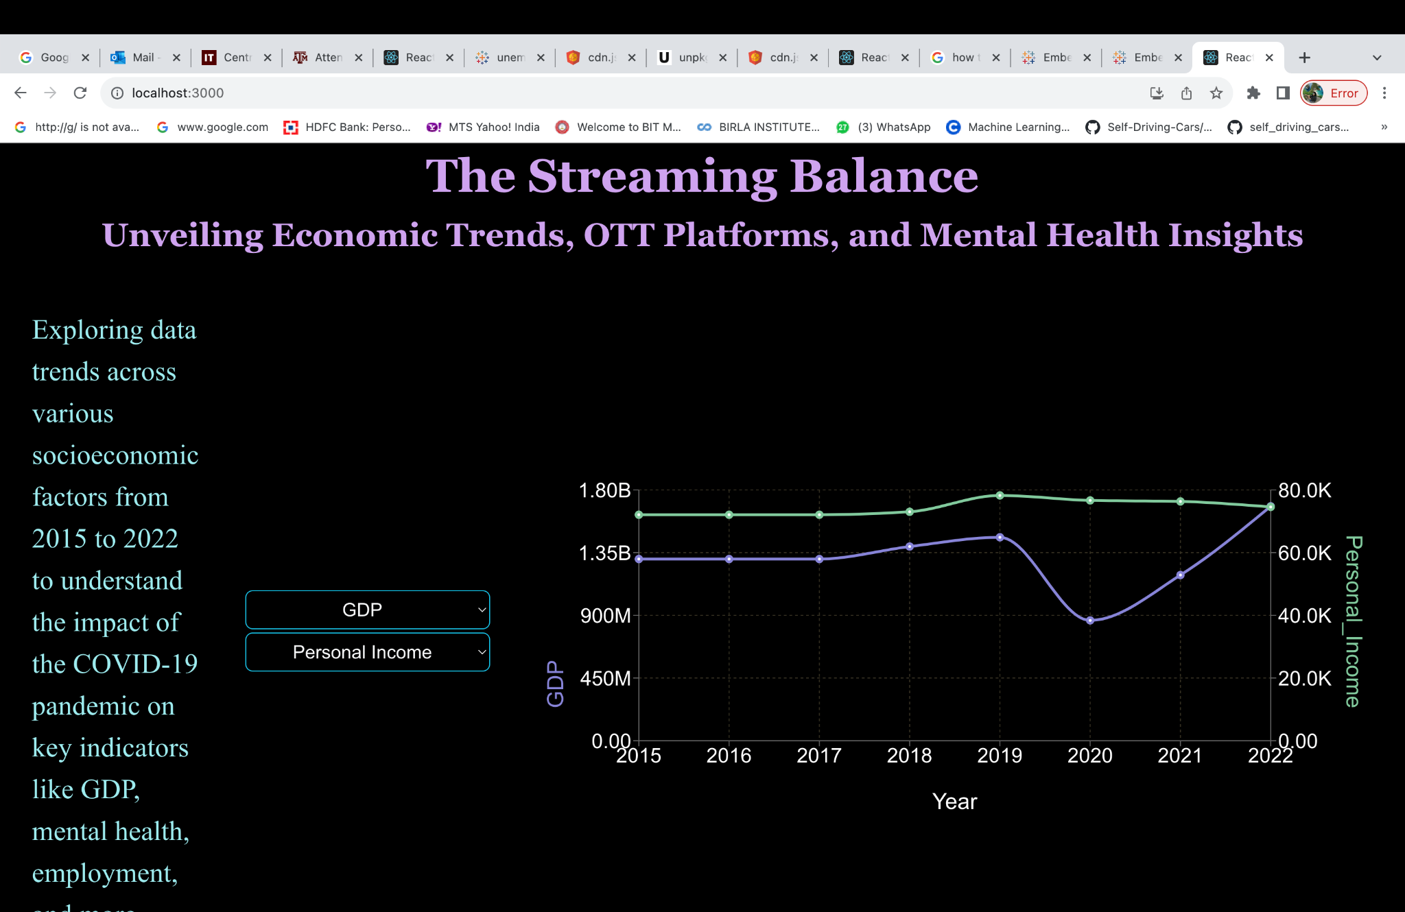

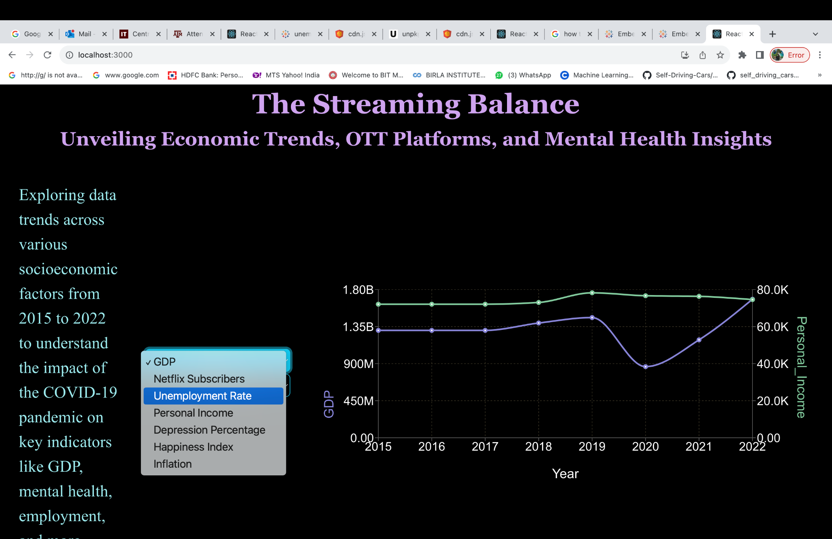

1. Interactive bar chart with select menu

This is an interactive bar chart that shows the contribution of different industries to the overall GDP of the United States. Users can select any industry to see its % contribution to GDP over the years.

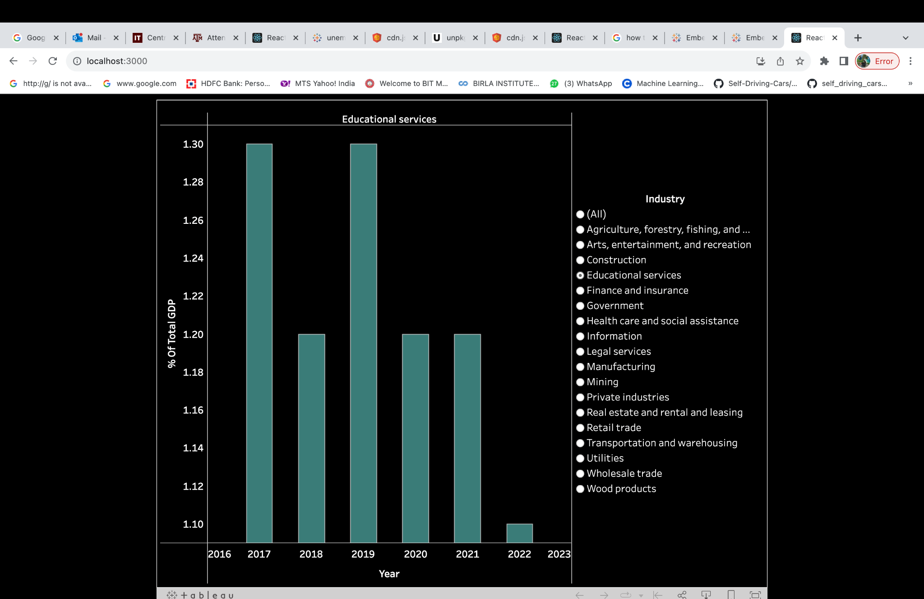

This visualization also offers to view comparisons among multiple industries. The users can select two or more industries from the right menu panel to analyze and compare any industries of their choice.

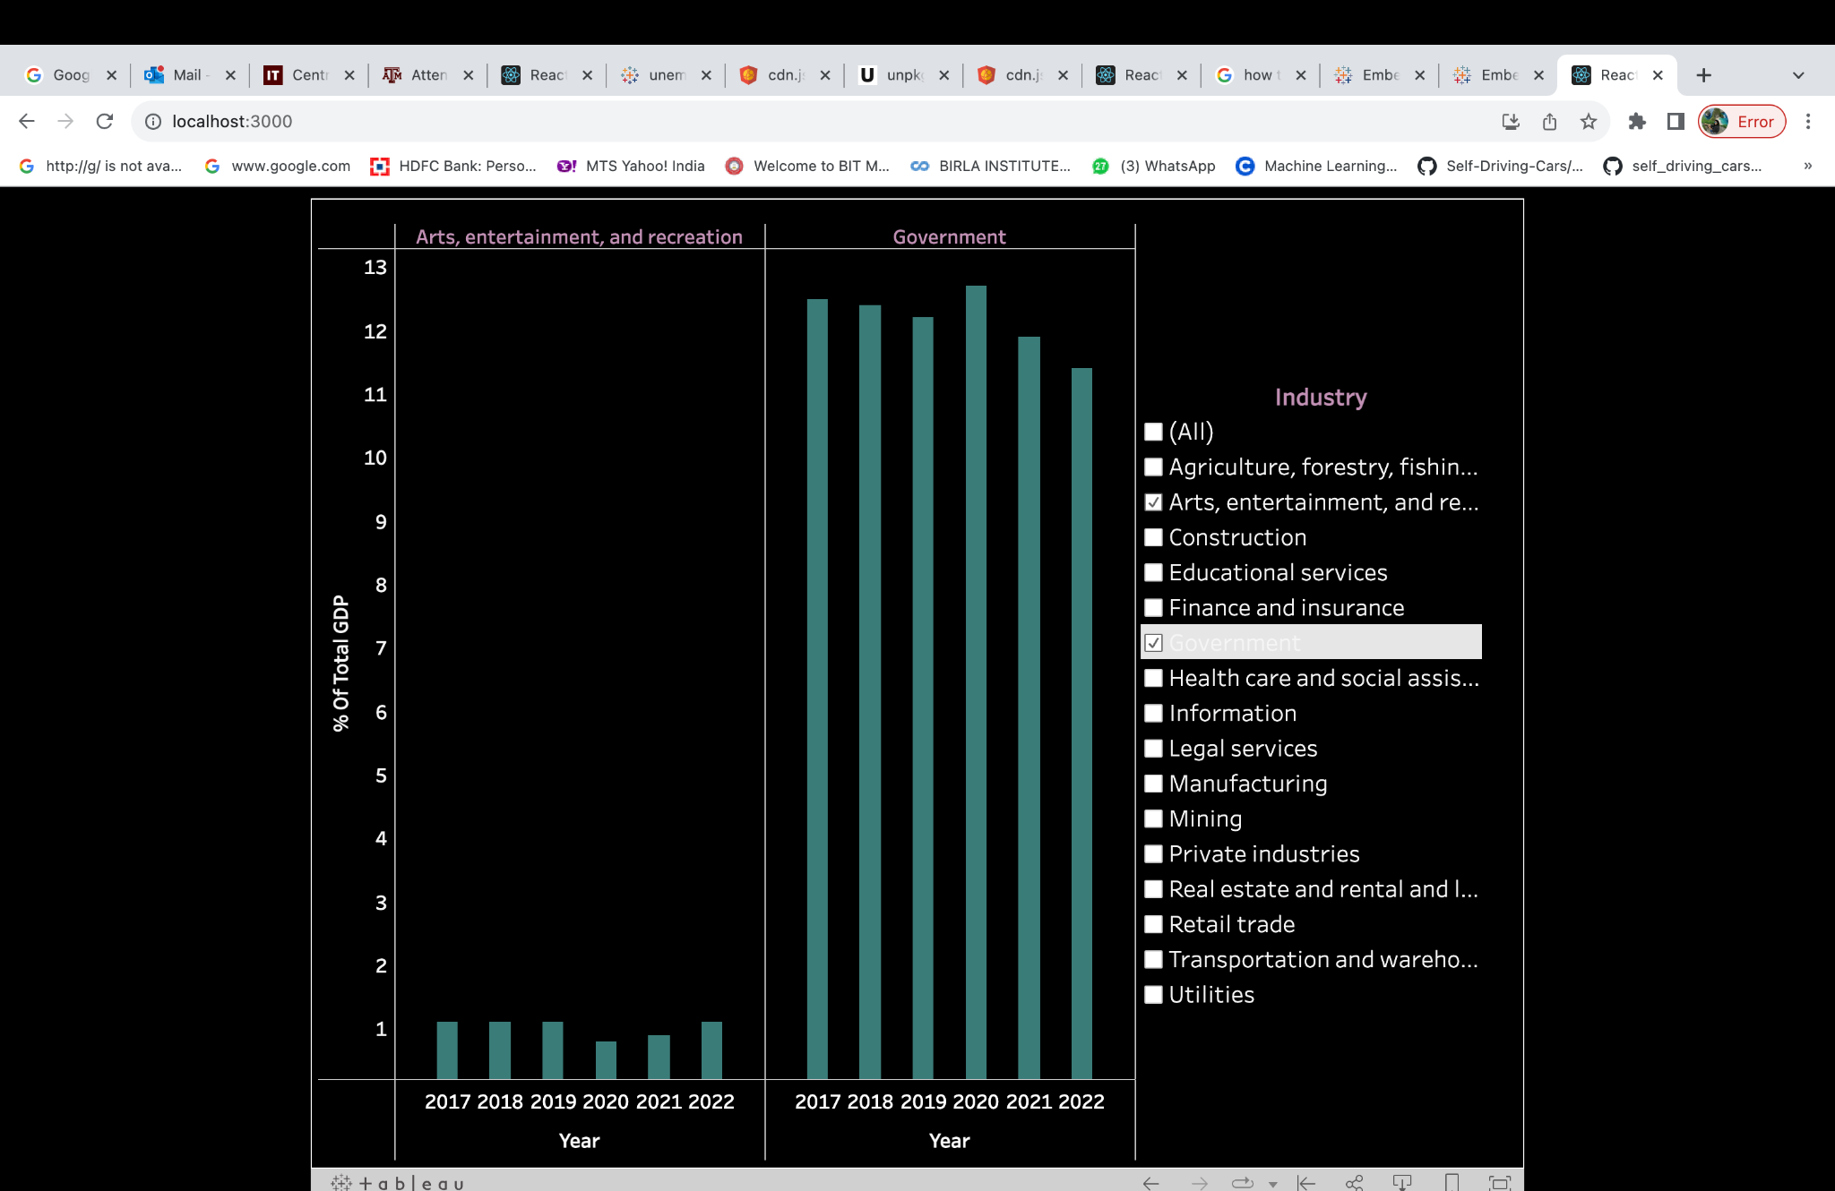

1. Interactive Choropleth map

This choropleth map is used to visualize the variation of unemployment rate in different states over the years (from 2013 to 2023). Users can use the drop-down, slider or click the play button to view trend over the years.

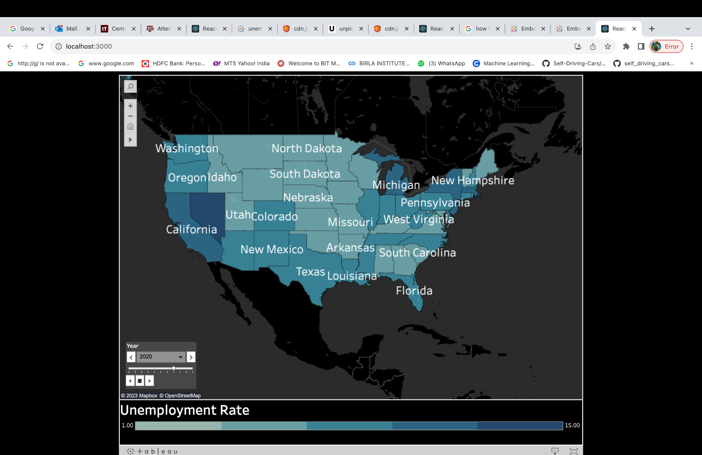

1. Interactive Choropleth map

This choropleth map allows the user to see the top-10 or bottom-10 happiest states for 2018 (pre-pandemic year) and 2022 (post-pandemic year). There is a drop-down menu with options for the users to select.

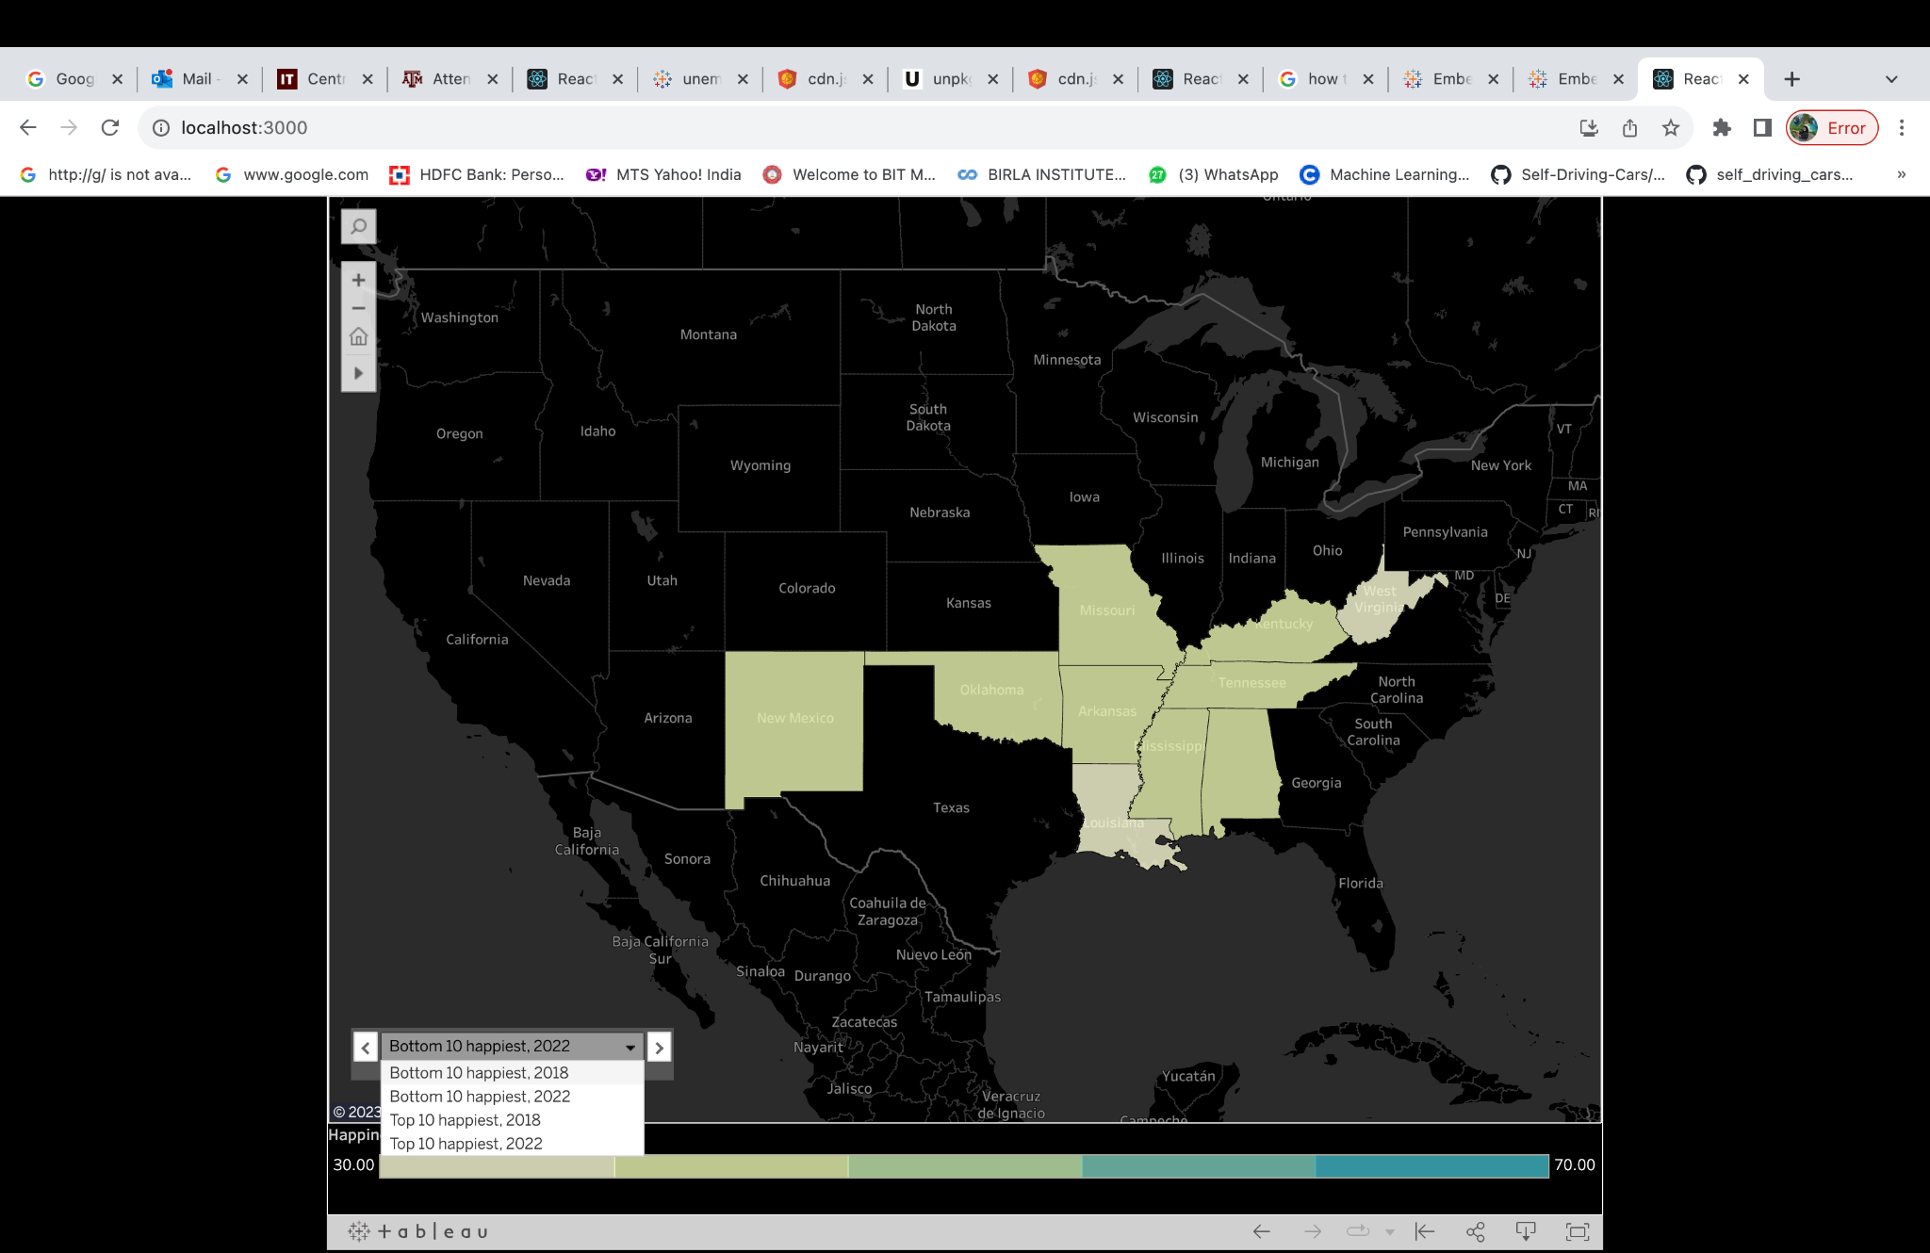

1. Bar chart

The below bar chart represents the average number of hours spent daily on OTT platforms in the US from 2018-2022.

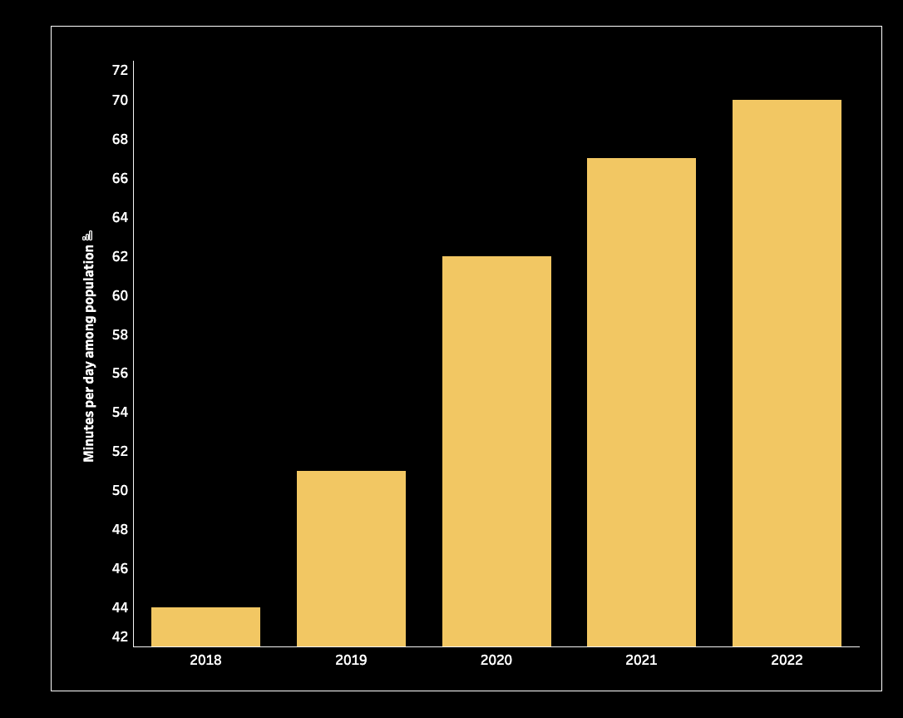

1. Stacked bar chart

There is a stacked bar chart which represents the percentage of various OTT platforms usage based on the gender (male and female). There is a select menu below where the user can either select male to only view the trends of male or select female or both.

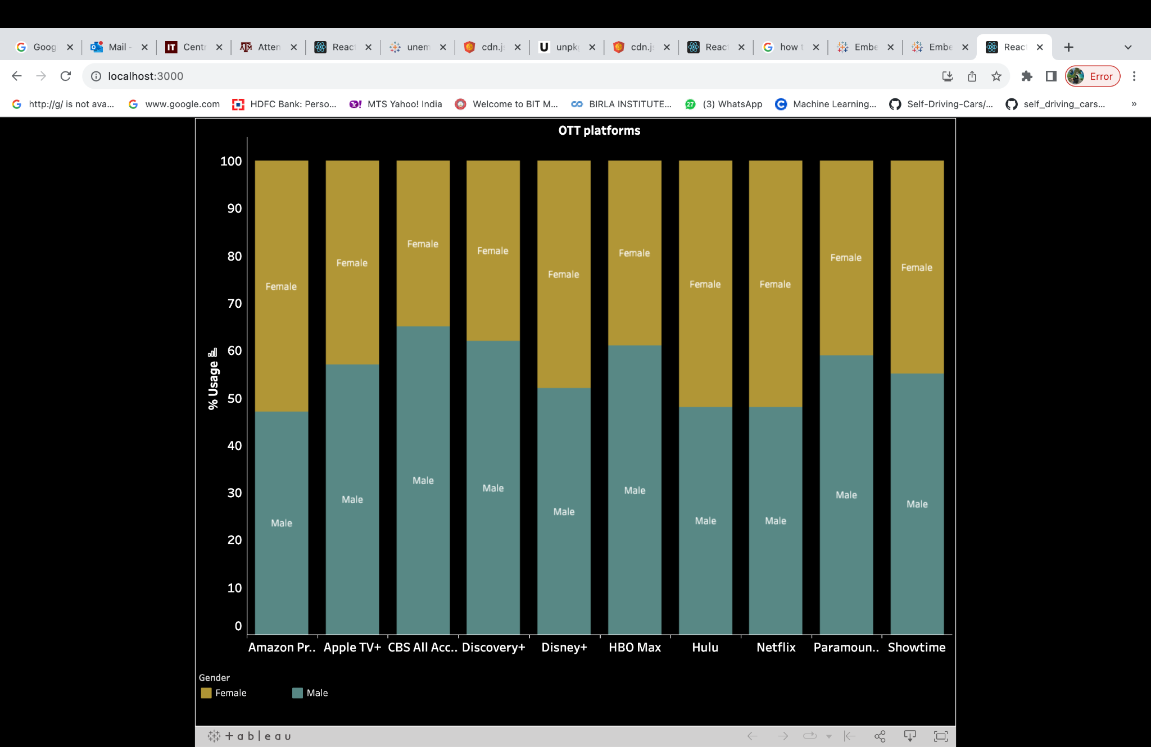

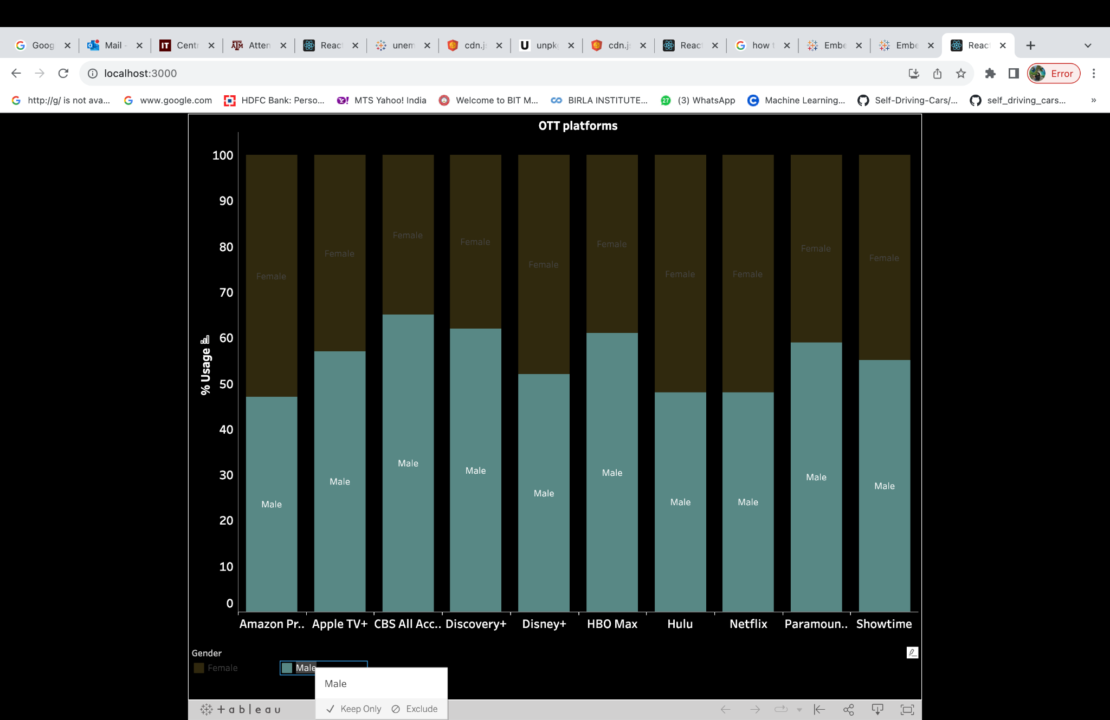

1. Horizontal Bar Chart

This chart shows the different categories such as Gender or Age, and draws the % change in depression rate between 2017 and 2023. This metric also helps to see the high level impact of pandemic on mental health.

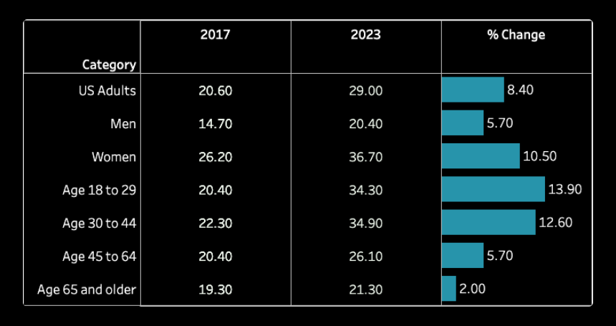

**Discussion of design decisions**

1. To see the correlation between several factors, wo chose an interactive biaxial chart. It is easy to understand and offers clear insights as well.
2. Our second goal was to visualize the state-wise variation of factors so we decided to create a choropleth maps.
3. Thirdly, for visualizing different other trends we created bar charts, line charts and stacked bar charts.
4. Using the Gestalt Principles Our design prioritized consistency (color, shape, size) for similar data points and employed smooth, continuous lines for visual flow. Interaction design featured feedback cues in the biaxial chart and intuitive affordance for exploring socioeconomic relations. Visual hierarchy emphasized key elements using size, color, or contrast and organized information logically to highlight critical details first.
5. Practical Limitations: Practical limitations arose when exploring the impact of COVID-19. Obtaining health datasets for 2020 and 2021 proved challenging due to changed metrics, rendering pre and post-COVID datasets incomparable. Additionally, OTT viewership data was restricted to paid accounts or unavailable publicly.

**Evaluation of your work:**

Our project evolved significantly over time, adapting to new visualization techniques and expanding beyond our initial plans. The 'Example of the Day' visualizations inspired us with fresh ideas, prompting adjustments to our central theme.

Originally focused on a simple biaxial chart, we transformed it into an interactive version, allowing users to explore correlations between various socioeconomic factors via dropdown menus. Initially centered on economic trends, OTT platforms, and mental health insights, we expanded our scope after discovering the profound impact of the COVID-19 pandemic on socioeconomic patterns. Additional visualizations were integrated into our project to capture these insights.

User feedback played a crucial role in refining our work. Minor adjustments, such as removing grid lines, increasing font size, and improving alignment, were made to enhance user interactivity and experience.

**Future Works:**

Given more time and resources, our ideal vision for the project involves making visualizations live and dynamic, ensuring real-time updates with the latest data. This would require implementing mechanisms to fetch and display the most recent information automatically. Additionally, we would expand the scope by incorporating additional socioeconomic factors, such as other economic indicators or relevant social data, for a more comprehensive understanding.

Encountering premium datasets presented limitations, but access to such data could unlock further interesting insights. The goal is to enhance the project's depth and interactivity, providing users with up-to-date and comprehensive visualizations.

**Software Tools:**

1. React: We have used react to create a webpage where we can host our different visualizations. We have some of the visualization using react.
2. Tableau: We have used tableau to create some of the visualizations.
3. Bootstrap, CSS: We have used bootstrap and css to enhance the design element of our website.
4. Github: We used github for source control and code deployment.
5. Microsoft Excel and Python: These were used for data cleaning and formatting.